Projeto Filtro IIR - Chebyshev I 1
Projeto Filtro FIR - PM 6
% %% Dados
% % BS - (fa = 6000 Hz, f1 = 1200 Hz; f2 = 1250 Hz, f3 = 1300 Hz; f4 = 1400 Hz, Ap = 0.5 dB, As = 60 dB, GdB = 0 dB)
% % IIR - Chebyshev I, FIR - PM

Projeto Filtro IIR - Chebyshev I
clear all;
close all;
clc;
Ap = 0.5; % Ganho na banda de passagem em dB
As = 60; % Atenuação no stopband em dB
fa = 6000; % Hz
f1 = 1200; % Hz
f2 = 1250; % Hz
f3 = 1300; % Hz
f4 = 1400; % Hz
GdB = 0; % dB
% Frequências
fs1 = f2;
fs2 = f3;
fp1 = f1;
fp2 = f4;
% Frequência -> omega
ws1 = 2*pi*fs1;
wp1 = 2*pi*fp1;
wp2 = 2*pi*fp2;
ws2 = 2*pi*fs2;
wa = fa*2*pi;
% Cálculo do tetha
tetha_s1 = ws1/(wa/2);
tetha_p1 = wp1/(wa/2);
tetha_s2 = ws2/(wa/2);
tetha_p2 = wp2/(wa/2);
% Cálculo do lambda
lambda_s1 = 2*tan(tetha_s1 * pi/2);
lambda_s2 = 2*tan(tetha_s2 * pi/2);
lambda_p1 = 2*tan(tetha_p1 * pi/2);
lambda_p2 = 2*tan(tetha_p2 * pi/2);
lambda_0 = sqrt(lambda_p2*lambda_p1);
lambda_s = min(lambda_s1,lambda_s2);
% Lowpass -> Bandstop
B = lambda_p2 - lambda_p1;
Os = abs((B*lambda_s)/(-lambda_s^2+lambda_0^2));
Op = 1;
% Filtro Chebyshev 1
Rp = Ap; Rs = As;
[n,Wn] = cheb1ord(Op,Os,Rp,Rs,'s');
[b,a] = cheby1(n,Rp,Wn,'s');
% Plot protótipo filtro PB
figure(1)
[h1,w1] = freqs(b,a,logspace(-2,1,1000));
semilogx(w1,20*log10(abs(h1)));grid on; ylim([-65 5]);
title('H(p)');hold on;xlabel('rad/s');ylabel('dB');
plot([10^-2,Os,Os,10^2],[0,0,-As,-As], '--r')
plot([10^-2,1,1],[-Ap,-Ap,-80], '--r')
% Transformação de frequência Lowpass para Bandstop
ap = a; bp = b;
syms p;
Np(p) = poly2sym(bp, p);
Dp(p) = poly2sym(ap, p);
Hp(p) = Np(p) / Dp(p);
pretty(vpa(collect(Hp(p)), 5))
% transformação de frequência
syms s;
Hs(s) = collect(subs(Hp(p),((B*s)/(s^2 + lambda_0^2))));%transformação lowpass/bandstop
[N, D] = numden(Hs(s));
pretty(vpa(Hs(s), 5))
% Normalizando de acordo com p^n
bs = sym2poly(N);
as = sym2poly(D);
an = as(1);
bsn = bs/an;
asn = as/an;
Hsn(s) = poly2sym(bsn, s)/poly2sym(asn, s);
pretty(vpa(Hsn(s), 5))
% Plot filtro BS
figure(2)
[h, w] = freqs(bsn,asn, linspace(0, 8, 10000));
plot(w/pi, 20*log10(abs(h))); grid on;hold on;ylim([-65 5]);xlim([0 2])
title('H(s)');xlabel('rad/s');ylabel('dB');
% Fazer a mascara em cima do LAMBDA
plot([0,lambda_s1/pi,lambda_s1/pi,lambda_s2/pi,lambda_s2/pi,2],-[0,0,As,As,0,0], '--r')
plot([0,lambda_p1/pi,lambda_p1/pi],-[Ap,Ap,80], '--r')
plot([lambda_p2/pi,lambda_p2/pi,2],-[80,Ap,Ap], '--r')
hold off;
syms z;
aux = 2*((z-1)/(z+1));
Hz(z) = collect(subs(Hs(s), aux));
pretty(vpa(Hz(z),3))
[Nz,Dz] = numden(Hz(z));
bz = sym2poly(Nz);
az = sym2poly(Dz);
an = az(1);
bzn = bz/an;
azn = az/an;
Hzn(z) = poly2sym(bzn,z) / poly2sym(azn,z);
pretty(vpa(Hzn(z),5))
figure(3)
subplot(211)
[hz, wz] = freqz(bzn,azn, linspace(0, pi, 1000));
plot(wz/pi*fa/2, 20*log10(abs(hz))); grid on;hold on;ylim([-65 5]);xlim([0 2e3]);
title_txt = ['BS - Filtro IIR - Chebyshev I - N = ' num2str(n*2)];
title(title_txt);xlabel('Hz');ylabel('dB');
% Máscara do filtro projetado
plot([0,f1,f1,f4,f4,2000],-[Ap,Ap,80,80,Ap,Ap], '--r')
plot([0,f2,f2,f3,f3,2000],-[0,0,As,As,0,0], '--r')
hold off;
subplot(212)
plot(wz/pi*fa/2, 20*log10(abs(hz))); grid on;hold on;ylim([-5 2]);xlim([998 1302]);
title_txt = ['BP - Filtro IIR - Chebyshev I - N = ' num2str(n*2)];
title(title_txt);xlabel('Hz');ylabel('dB');
% Máscara do filtro projetado
plot([0,f1,f1,f4,f4,2000],-[Ap,Ap,80,80,Ap,Ap], '--r')
plot([0,f2,f2,f3,f3,2000],-[0,0,As,As,0,0], '--r')
hold off;
figure(4)
subplot(121)
zplane(bzn, azn);title('Diagrama de pólos e zeros');xlabel('Parte real');ylabel('Parte imaginária');axis([-2 2 -3 3]);
subplot(122)
grpdelay(bzn, azn);title('Atraso de grupo');
xlabel('Frequência normalizada [x\pi rad/amostra]');
ylabel('Atraso de grupo [amostra]');
15 16 7 16 6 17 5
(3.2232 10 )/(7.2058 10 p + 8.2954 10 p + 1.7385 10 p
17 4 17 3 16 2 16
+ 1.3471 10 p + 1.1874 10 p + 5.445 10 p + 2.0325 10 p
15
+ 3.2232 10 )
122 12 123 10 123 8 124 6
(#1 + 1.3541 10 s + 1.063 10 s + 4.6358 10 s + 1.2131 10 s
124 4 124 2 123
+ 1.9046 10 s + 1.6612 10 s + 6.21 10 )/(#1
121 13 122 12 122 11 123 10
+ 1.621 10 s + 1.5051 10 s + 2.6595 10 s + 1.265 10 s
123 9 123 8 123 7 124 6
+ 1.7867 10 s + 5.7055 10 s + 6.2898 10 s + 1.493 10 s
124 5 124 4 124 3 124 2
+ 1.2234 10 s + 2.2666 10 s + 1.2469 10 s + 1.8465 10 s
123 123
+ 5.2038 10 s + 6.21 10 )
where
120 14
#1 == 7.3924 10 s
14 12 10 8 6 4
(s + 18.317 s + 143.79 s + 627.11 s + 1641.0 s + 2576.4 s
2 14 13 12 11
+ 2247.2 s + 840.06)/(s + 2.1927 s + 20.36 s + 35.976 s
10 9 8 7 6 5
+ 171.13 s + 241.7 s + 771.81 s + 850.85 s + 2019.6 s + 1655.0 s
4 3 2
+ 3066.2 s + 1686.7 s + 2497.8 s + 703.94 s + 840.06)
126 14 127 13 127 12 127 11
(4.1 10 z - 1.2 10 z + 4.38 10 z - 8.26 10 z
128 10 128 9 128 8 128 7
+ 1.66 10 z - 2.23 10 z + 3.08 10 z - 3.05 10 z
128 6 128 5 128 4 127 3
+ 3.08 10 z - 2.23 10 z + 1.66 10 z - 8.26 10 z
127 2 127 126 126 14
+ 4.38 10 z - 1.2 10 z + 4.1 10 )/(7.79 10 z
127 13 127 12 128 11 128 10
- 2.08 10 z + 6.85 10 z - 1.18 10 z + 2.14 10 z
128 9 128 8 128 7 128 6
- 2.63 10 z + 3.29 10 z - 2.98 10 z + 2.73 10 z
128 5 128 4 127 3 127 2
- 1.8 10 z + 1.22 10 z - 5.5 10 z + 2.63 10 z
126 126
- 6.52 10 z + 1.99 10 )
14 13 12 11 10 9
(0.52687 z - 1.542 z + 5.6223 z - 10.6 z + 21.299 z - 28.663 z
8 7 6 5 4 3
+ 39.493 z - 39.212 z + 39.493 z - 28.663 z + 21.299 z - 10.6 z
2 14 13 12
+ 5.6223 z - 1.542 z + 0.52687)/(z - 2.665 z + 8.7946 z
11 10 9 8 7 6
- 15.096 z + 27.532 z - 33.758 z + 42.278 z - 38.258 z + 35.029 z
5 4 3 2
- 23.152 z + 15.613 z - 7.0565 z + 3.381 z - 0.83694 z + 0.25579)
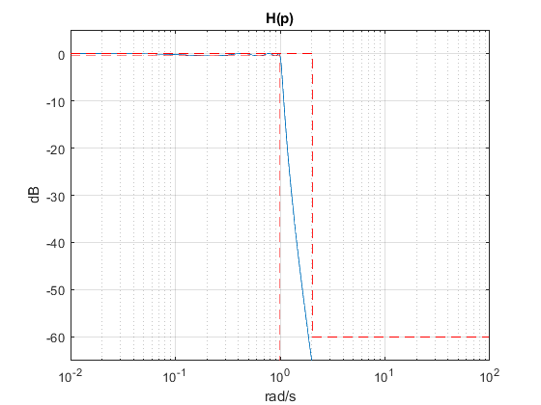
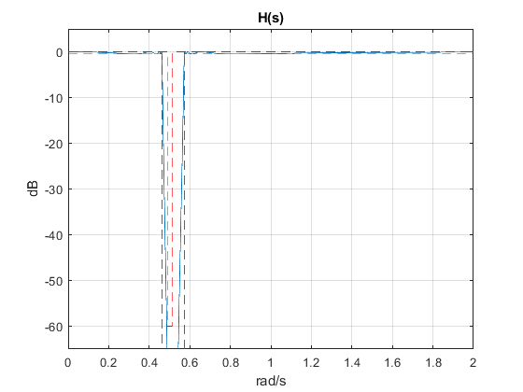
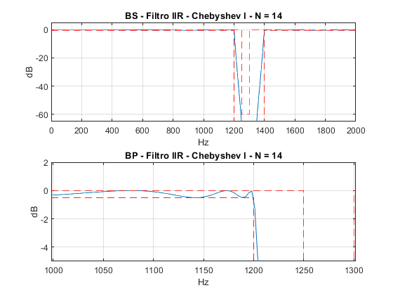
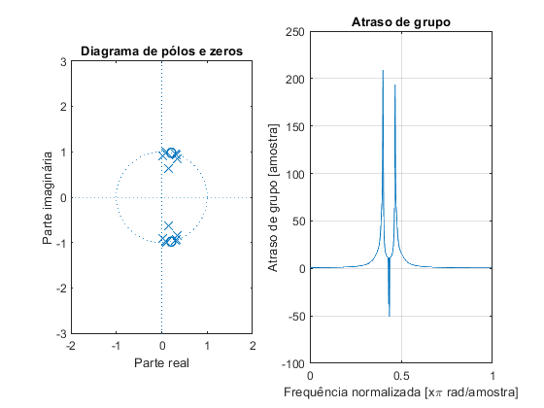

Projeto Filtro FIR - PM
clear all;
clc;
Ap = 0.5; % Ganho na banda de passagem em dB
As = 60; % Atenuação no stopband em dB
fa = 6000; % Hz
f1 = 1200; % Hz
f2 = 1250; % Hz
f3 = 1300; % Hz
f4 = 1400; % Hz
GdB = 0; % dB
f = [1200 1250 1300 1400]; % frequências em Hz
w = f/fa*(2*pi);
ws1 = w(1)/pi;
wp1 = w(2)/pi;
wp2 = w(3)/pi;
ws2 = w(4)/pi;
mags = [1 0 1];
% [n,fo,ao,w] = firpmord(f,a,dev,fs)
devAs = 10^(-(As-3.5)/20);
devAp = 1-10^(-(Ap/2+0.05)/20);
devs = [devAp devAs devAp];
% calculo da ordem com firpmord
f = f + [0 0 40 0];
[n,f0,a0,w0] = firpmord(f,mags,devs,fa);
G0 = -Ap/2;
% calculo algoritmo PM
h_pm = firpm(n,f0,a0,w0);
h_pm = h_pm*10^(G0/20);
%clear Hw W
figure(4)
subplot(211)
[Hw,w] = freqz(h_pm,1,10000);
plot(w*fa/2/pi,20*log10(abs(Hw)))
title_txt = ['BS - Filtro FIR - PM - N = ' num2str(n)];
title(title_txt);xlabel('Hz');ylabel('dB');
hold on;
% Máscara
Amin = 0;
plot([0,f1,f1,f4,f4,fa/2],-[Ap,Ap,80,80,Ap,Ap], '--r');ylim([-80 5]);xlim([1000 1600]);
plot([0,f2,f2,f3,f3,fa/2],[Amin,Amin,-As,-As,Amin,Amin], '--m');grid on;
hold off;
subplot(212)
[Hw,w] = freqz(h_pm,1,10000);
plot(w*fa/2/pi,20*log10(abs(Hw)));ylim([-65 -55]);xlim([1225 1375]);
title_txt = ['BS - Filtro FIR - PM - N = ' num2str(n)];
title(title_txt);xlabel('Hz');ylabel('dB');
hold on;
% Máscara
plot([0,f1,f1,f4,f4,fa/2],-[Ap,Ap,80,80,Ap,Ap], '--r');
plot([0,f2,f2,f3,f3,fa/2],[0,Amin,-As,-As,Amin,0], '--m');grid on;
hold off;
figure(6)
subplot(121)
zplane(h_pm,1);title('Diagrama de pólos e zeros');xlabel('Parte real');ylabel('Parte imaginária');axis([-2 2 -3 3]);
subplot(122)
grpdelay(h_pm,1);title('Atraso de grupo');
xlabel('Frequência normalizada [x\pi rad/amostra]');
ylabel('Atraso de grupo [amostra]');
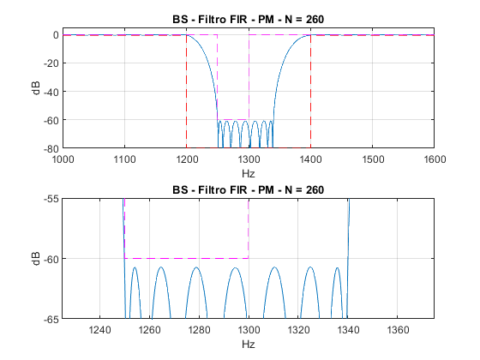
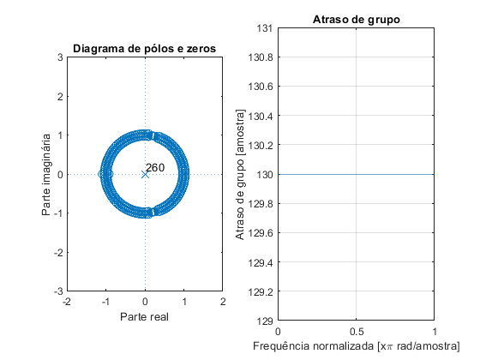
Published with MATLAB® R2018a

